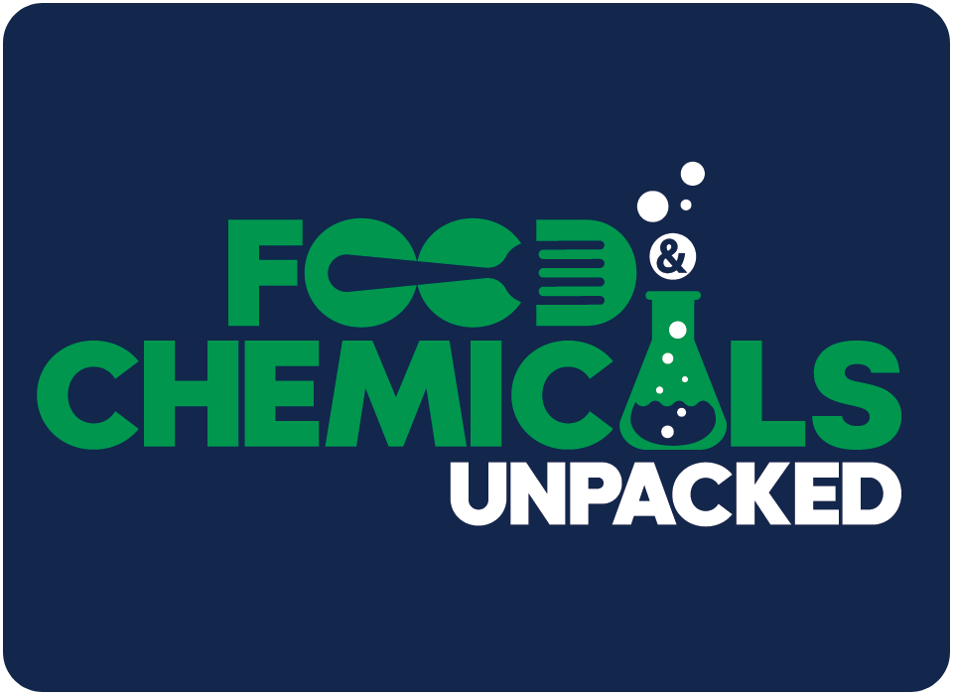
Much Ado About TiO2
Intro (0:00 – 3:01 min)
- Daily Intake Blog: FDA Publishes Stance on Titanium Dioxide in Food
Background of TiO2 (3:01 – 4:46 min)
- TiO2 Espionage Story
Safety of TiO2 and EU Activity/Ban (4:46 – 13:46 min)
- U.S. Food and Drug Administration (FDA)
  - Daily Intake Blog: FDA Publishes Stance on Titanium Dioxide in Food
- European Chemicals Agency (ECHA)
  - CLH report: Proposal for Harmonised Classification and Labelling Based on Regulation (EC) No 1272/2008 (CLP Regulation), Annex VI, Part 2, Substance Name: Titanium dioxide
  - Commission Delegated Regulation (EU) 2020/217 of 4 October 2019 amending, for the purposes of its adaptation to technical and scientific progress, Regulation (EC) No 1272/2008 of the European Parliament and of the Council on classification, labelling and packaging of substances and mixtures and correcting that Regulation (Text with EEA relevance)Text with EEA relevance
- European Court of Justice (CEJU) cases on inhalation classification
  - The General Court annuls the Commission Delegated Regulation of 2019 in so far as it concerns the harmonised classification and labelling of titanium dioxide as a carcinogenic substance by inhalation in certain powder forms (europa.eu)
  - Appeal brought on 8 February 2023 by the French Republic against the judgment of the General Court
- France
  - Order of December 27, 2023 suspending the marketing of foodstuffs containing the additive E 171 (titanium dioxide - TiO2)
  - Directorate General for Competition, Consumer Affairs and Fraud Prevention (DGCCRF) Titanium dioxide in foodstuffs: everything must disappear
  - USDA GAIN Report (dated May 8, 2019): France Bans Titanium Dioxide in Food Products by January 2020
  - French Law no. 2018-938 of October 30, 2018 for the balance of commercial relations in the agricultural and food sector and healthy, sustainable and accessible food for all
- Opinions from the French Agency for Food, Environmental and Occupational Health & Safety (ANSES)
  - Titanium dioxide nanoparticles in food (additive E171): biological effects need to be confirmed
  - Establishment of Chronic Reference Value by inhalation for Titanium Dioxide under nanoform
  - Food additive E171: ANSES reiterates its recommendations for consumer safety
  - Opinion on a specific health risk assessment guide for nanomaterials in food products
- EU Ban on TiO2 as a food additive
  - USDA GAIN Report (dated March 3, 2022): Titanium Dioxide Banned as a Food Additive in the EU
- WHO Statement JECFA’s risk assessment of titanium dioxide risk released (dated 24 November 2023)
TiO2 Activity at the State Level (13:46 – 16:51 min)
- U.S. Food and Drug Administration (FDA)
  - FDA Announcement: Titanium Dioxide as a Color Additive in Foods
  - 21 C.F.R. Section 73.575 -- Titanium dioxide
  - 21 C.F.R. Section 178.3297 -- Colorants for polymers
Dr. Ivan Boyer - Details on TiO2 Data and Risk Assessments (16:51 – 25:50 min)
- Opinions by the European Food Safety Authority (EFSA)
  - Re-evaluation of titanium dioxide (E 171) as a food additive (Published 14 September 2016)
  - Evaluation of four new studies on the potential toxicity of titanium dioxide used as a food additive (E 171) (Published 4 July 2018)
  - Safety assessment of titanium dioxide (E171) as a food additive (Published 6 May 2021)
Conclusion and Upcoming Events (25:50 – 28:36 min)
- 2024 Paper Packaging Seminar (May 14-15, 2024)

