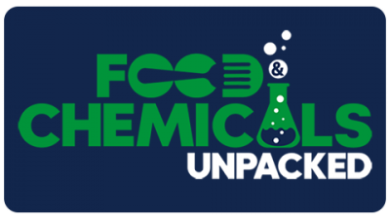
Show Notes for Episode 2: Chasing Arrows – The EU’s Plastic Recycling Scheme
Intro (0:00 – 1:57 min)
Trade press (1:57 – 7:42 min)
- FDA Announces Enforcement Discretion for Genome-Edited Beef Cattle (2:27 – 3:53)
- Dangerous PFAS Chemicals Are in Your Food Packaging - Consumer Reports (3:53 – 5:27)
- Sugar Association Files Supplemental Petition Urging Regulatory Changes for Artificially Sweetened Foods (5:27 – 6:37)
- FDA Releases Report on Guacamole Sampling (6:37 – 7:42)
Feature on EU Recycling (7:42 – 32:02 min)
- Different methods of plastic recycling (7:42 – 11:26)
- Overview of surrounding EU regulatory scheme (11:26 – 13:48)
- Explanation of draft EU Plastics Recycling Regulation (13:48 – 32:02)
Upcoming Events (32:02 – 33:11 min)
- U.S. Practical Food Law Seminar (May 3-5, 2022, San Francisco, California)
- 6th Annual Paper Packaging Law Seminar (May 18-19, 2022, Chicago, Illinois)

